

**Music Development Plan 2024-25**

***Building strong foundations for the future***

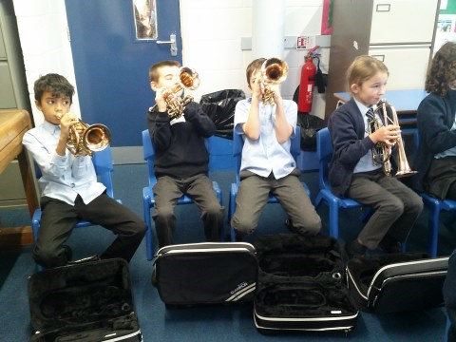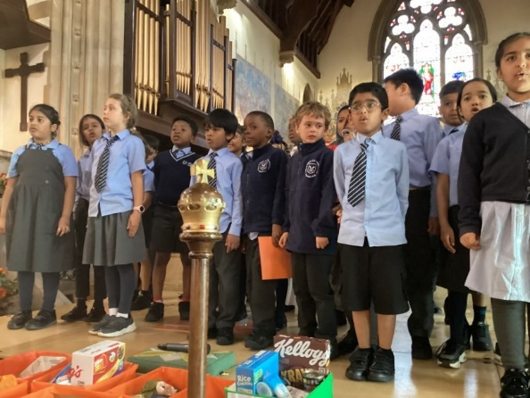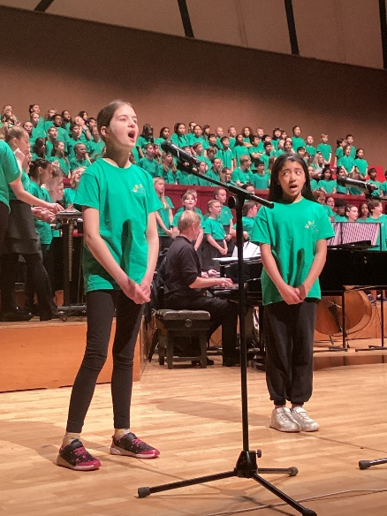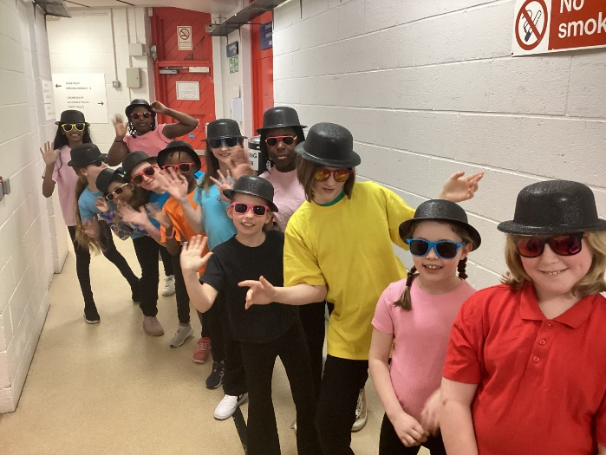

# 

# Music Development Plan: Earley St Peter’s CofE Primary School

## Overview

|  |  |
| --- | --- |
| Detail | Information |
| Academic year that this summary covers | 2024-2025 |
| Date this summary was published | 9th September 2024 |
| Date this summary will be reviewed | September 2025 |
| Name of the school music lead | Mrs Sarah Tolladay |
| Name of local music hub | Berkshire Music Trust |
| Name of other music education organisation(s) (if partnership in place) | Earley Music School are based at Earley St Peter’s  Wokingham Area School Music Association |

This is a summary of how our school delivers music education to all our pupils across three areas – curriculum music, co-curricular provision and musical experiences – and what changes we are planning in future years. This information is to help pupils and parents or carers understand what our school offers and who we work with to support our pupils’ music education.

## Part A: Curriculum music

This is about what we teach in lesson time, how much time is spent teaching music and any music qualifications or awards that pupils can achieve.

|  |
| --- |
| **Curriculum Music Overview:**  Earley St Peters Primary School, Wokingham, is committed to providing high-quality music education to all students. Our curriculum is designed in alignment with the non-statutory guidance of the Model Music Curriculum (March 2021) for Key Stages 1 to 3. We use resources from this alongside the scheme Music Express. Music plays an important part within our school curriculum, being taught across all year groups each year.  **Year Group Allocation:**   * **Key Stage 1:** 1 hour per week, half termly. * **Key Stage 2:** 1 hour and 45 minutes, bi-weekly.   **Opportunities for Learning:**   * Whole-class ensemble teaching (WCET) is provided in Year 4, where pupils are taught to play brass instruments weekly. They end their unit of learning with a performance to parents as part of a brass ensemble. Pupils also have the opportunity to deepen their learning by continuing to learn a brass instrument through private lessons provided in school. * Singing is an integral part of the curriculum with weekly singing assemblies and classroom-based singing activities.   **Partnerships:**   * Our school works closely with the Berkshire Music Trust, which provides specialist music teachers for our WCET programs along with private 1:1 piano, woodwind, violin and brass lessons. Children are entered for ABRSM grades individually when ready. * Our school has close links to Earley Music School which takes place on site every Saturday providing group activities for children in the local area.   **Inclusivity:**   * We ensure access for disabled pupils and support for those with special educational needs (SEND). Our music curriculum is differentiated to meet diverse learning needs. |

## Part B: Co-curricular music

This is about opportunities for pupils to sing and play music, outside of lesson time, including choirs, ensembles and bands, and how pupils can make progress in music beyond the core curriculum.

|  |
| --- |
| **Music Tuition:**   * **Individual and Group Lessons:** Available for piano and guitar. These lessons are offered through Berkshire Music Trust. * **Tuition Details:** We promote remissions schemes for families eligible for Pupil Premium funding.   **Ensembles and Choirs:**   * **Choirs:** 2 Key Stage Two Choirs run throughout the year, culminating in performances at Woodley Music Festival and Wokingham Area School Music Association (WASMA) concerts where the school collaborates with other schools cross the borough at the Hexagon in Reading. * **Joining Information:** Pupils can join choir from Year 3 onwards. Participation is free of charge to ensure funding is not a barrier for any pupil. Children have the option to join massed choir concerts with children from other schools as well as our own concerts at the Christmas and Summer Fayres.   **Rehearsal and Practice Spaces:**   * We provide designated spaces for rehearsals and individual practice in our music room. Choir practice happens in a classroom as more space is needed.   **Partnerships:**   * Collaboration with Berkshire Music Trust for brass teaching and additional performance opportunities. * Collaboration with other choirs within the trust to participate in the TKAT Annual Service. * Collaboration with the local church who have run singing workshops with the children in Year 3 and 4. |

## Part C: Musical experiences

This is about all the other musical events and opportunities that we organise, such as singing in assembly, concerts and shows, and trips to professional concerts.

|  |
| --- |
| **Regular Events:**   * **Assemblies:** Weekly singing assemblies for all year groups. Pupils perform seasonal songs with their peers. A wide range of music from different genres and ages is played for pupils to appreciate as they enter assembly. Prompt questions encourage pupils to reflect on the compositional elements of each piece and the feelings it provokes – see example in Appendix A. * **Individual tuition:** Individual children who have been learning to play a musical instrument both inside and outside school perform in whole school assemblies led by their music teachers. * **School Performances:** * **Brass**: At the end of the Autumn term Year 4 performs to their parents to showcase their learning from their whole class brass lessons. * **Singing**: All year groups lead a service in the church in front of their peers and parents. These services include a range of songs that pupils sing. Pupils are given opportunities to perform solos, in groups or as a year group. * **Choir Performances:** The school choir performs in annual Autumn and Summer concerts as well as a massed choir concert in the Spring term. * **Musical Shows:** Year 6 perform their annual musical in the summer term, Reception perform Christmas songs in the Autumn term and Nursery and Key Stage 1 perform their Christmas play annually.   **Trips and External Performances:**   * **Participation:** Children from Year 4 and above can participate in the Junior Music Festival run by the Berkshire Music Trust. Costs are subsidised with free participation for Pupil Premium eligible families. * **WASMA**: Children in year 3 and above have the opportunity to participate in a massed choir concert at the Hexagon with other local schools. * **Annual Church services:** Children are invited to attend carol concerts performed in the local church.   **Partnerships:**   * Partnership with Berkshire Music Trust for organising the Junior Music Festival. |

## In the future

This is about what the school is planning for subsequent years.

|  |
| --- |
| **Planned Improvements:**   * Review the use of instruments within music lessons so pupils gain experience using a wide variety of percussion, woodwind and technology to support teaching and learning in music. * Provide opportunity for pupils to see live musical performances.   **Focus Areas:**   * Expanding partnerships with additional music education organisations. * Continuing professional development for staff to enhance music teaching skills. * Further inclusion efforts to ensure all pupils, including Pupil Premium, have full access to wider musical opportunities. |

## Further information (optional)

|  |
| --- |
| For more details about Earley St Peter’s CE Primary School Music Development Plan, contact our Music Lead, Mrs Sarah Tolladay, via the school office: [admin@earley-st-peters.wokingham.sch.uk](mailto:admin@earley-st-peters.wokingham.sch.uk) |

### Appendix A – Assembly Intro Music

