Curriculum Intent: English

Broad and Ambitious Curriculum

At Earley St Peter’s, we believe an inspiring English curriculum is essential for developing pupils’ love of reading, writing and oracy. Our aim is to provide pupils with opportunities to grow intellectually, emotionally and socially through the study of English. English is taught both as a discrete subject and through integration with other curriculum areas, for example, Year 2 write poems on Remembrance Day, Year 5 write reports in Science and Year 6 write instructions in History. We emphasise the importance of creating an enriched environment where pupils take pride in their writing and adapt their style for various contexts. Reading is considered a key skill as it enables pupils to access all areas of the curriculum. Oracy and vocabulary development are central to our approach, with a strong focus on their impact on learning and personal growth.

Our curriculum incorporates the National Curriculum aims for English, ensuring all pupils:
- read fluently with good understanding
- develop the habit of reading widely and often for pleasure and information
- acquire a broad vocabulary, a solid understanding of grammar and knowledge of linguistic conventions
- appreciate a rich and varied literary heritage
- write clearly, accurately and coherently for a range of contexts, purposes and audiences
- use discussion as a tool for learning, explaining and elaborating on their ideas
- become competent in speaking and listening, including making presentations and participating in debates.

Planning and Implementation

In EYFS and Key Stage 1 synthetic phonics is taught using the ‘Essential Letters and Sounds’ scheme. This systematic approach focuses on letter sounds, blending for reading and segmenting for spelling. Pupils learn to read common exception words, master the 44 phonemes and progress to learning alternative sounds. They write daily, practising handwriting and rehearsing what they want to write before spelling words using known graphemes and tricky words. Pupils in Year 3 and 4 continue to access Phonics intervention as required.

Pupils’ reading skills are developed continuously from Reception to Year 6 through whole-class reading sessions. These sessions expose pupils to a variety of genres and help develop vocabulary, inference, prediction, explanation and retrieval skills. Pupils are also taught about text structure, and how to sequence, summarise and make links between texts. Teachers introduce new vocabulary before reading, enhancing pupils’ understanding and responses. The teaching of writing is supported by The Write Stuff approach by Jane Considine, which provides pupils with a structured and engaging framework for developing high-quality writing. This approach focuses on developing specific writing skills through modelling and practising sentence construction and composition techniques. Pupils are encouraged to create well-structured pieces of writing by focusing on purpose, audience and effective use of language. Tier 2 and Tier 3 vocabulary, underpinned by research by Isobelle Beck et al – Bringing Words to Life, are explicitly taught and pupils use resources such as dictionaries and thesauruses to support writing.

Strategies based on cognitive science, including low-stakes testing, are used to consolidate learning in pupils’ long-term memory. Oracy skills are developed through discursive and presentational activities. Pupils’ learning experiences are further enriched by providing high-quality reading texts and drama workshops.

Impact

Through a well-planned English curriculum, pupils at Earley St Peter’s develop culturally, emotionally, intellectually, socially and spiritually. By engaging with carefully selected high-quality literature, and through the planning of ‘Experience Days’, pupils build cultural capital, acquire knowledge and develop fluency in reading, writing and speaking. This enables them to communicate confidently and participate fully in society. The use of The Write Stuff approach ensures that pupils develop a love for writing and produce high-quality written work.

Assessment
Pupils’ knowledge and understanding are assessed continuously throughout the year through observations, discussions and written outcomes. Teachers update each pupil’s progress regularly and use summative assessments to evaluate whether pupils are working at age-related expectations. Attitudes towards learning English are also assessed and reported to parents during Parents Evenings and in an annual written report.

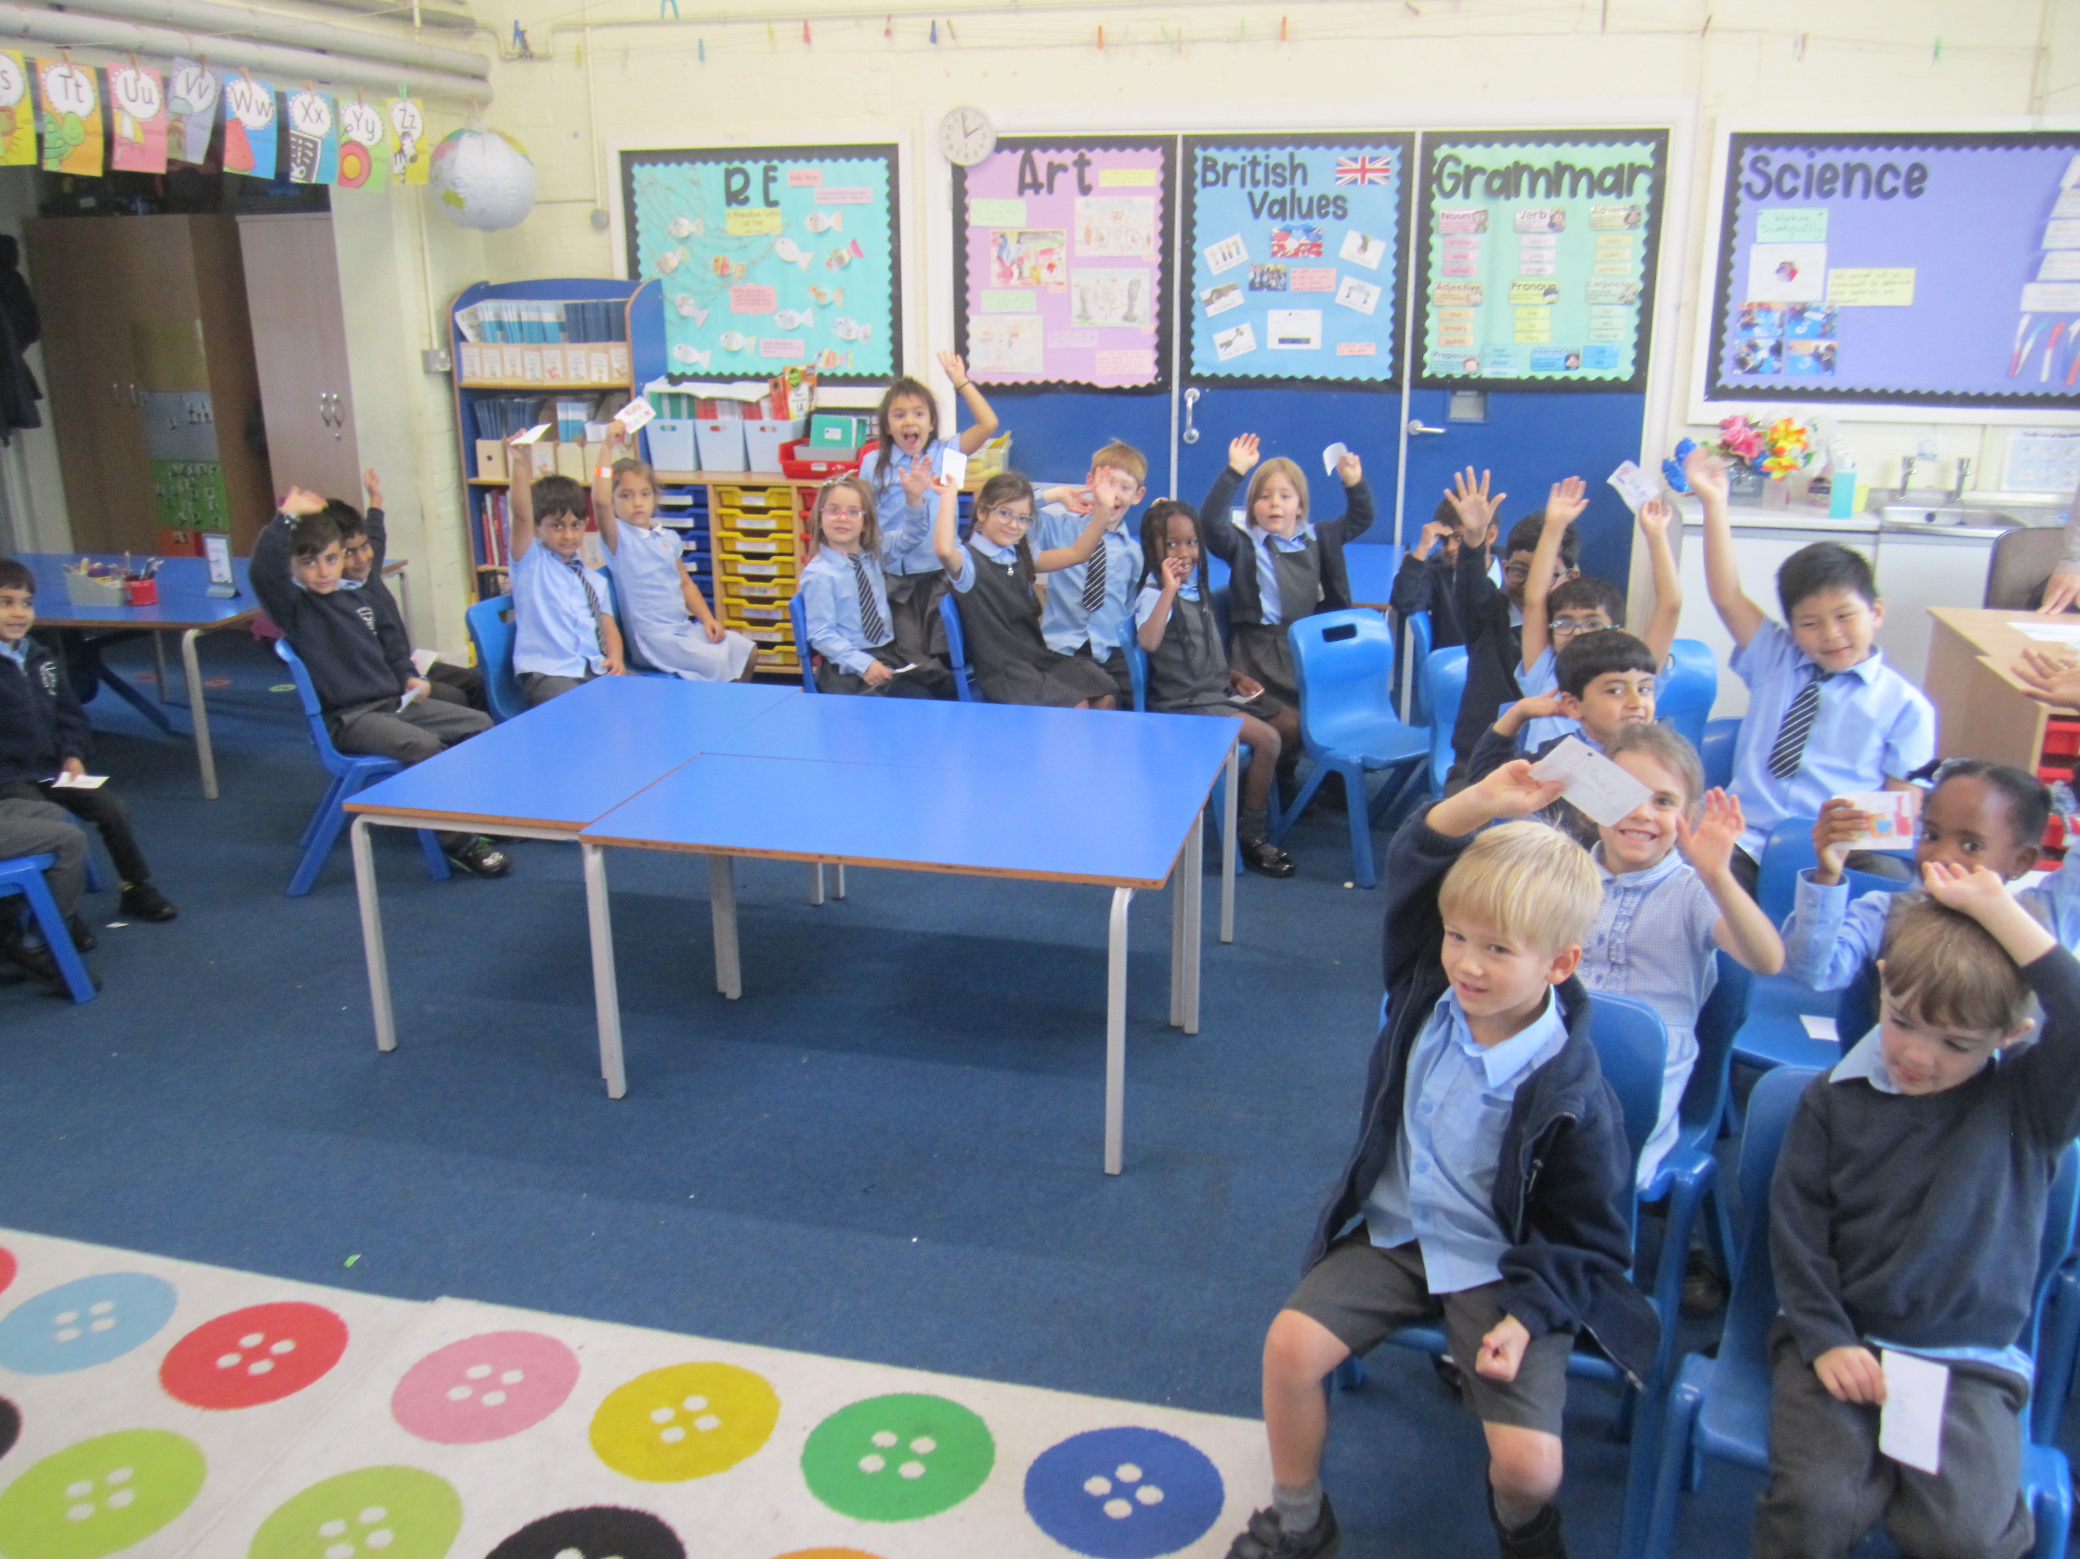 | 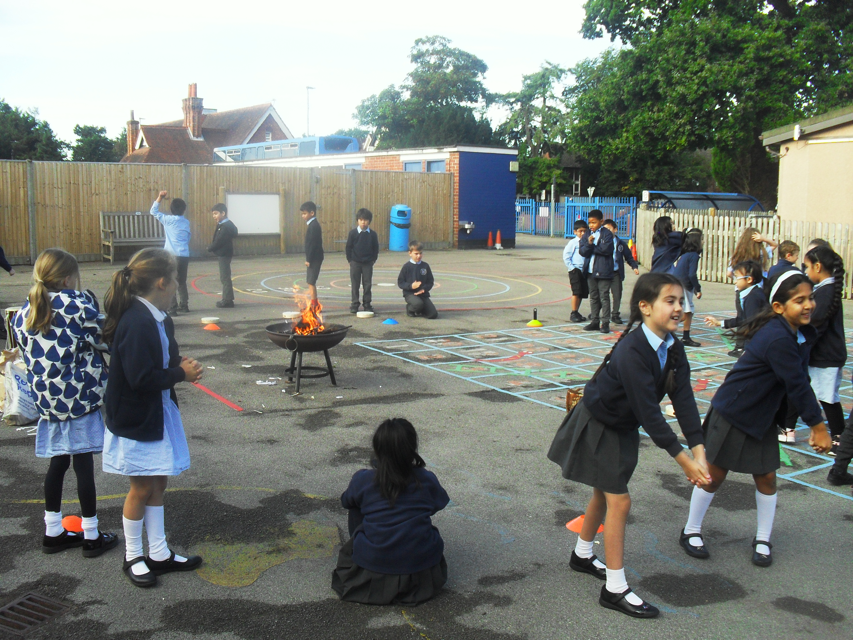 | 